Mediator Design Pattern — Build Chat Room — LLD + Code — Complete Notes

Introduction
The Mediator Design Pattern is simple but very useful. It solves a specific class of problems: when multiple objects need to interact with each other, they become tightly coupled if they hold references to each other directly.
Core problem solved: Reduces coupling between communicating objects by introducing an intermediary (the mediator).

The Problem — Why We Need Mediator

Communication Between Objects (Without Mediator)
Basic OOP communication: Objects communicate by calling each other's methods.
- OB1 calls a method M1 on OB2
- OB2 replies (e.g., "Hello")
- OB1 must have a reference to OB2 (ob2)
- OB2 must have a reference to OB1 (ob1)
With 2 objects: 1 connection each way (n-1 = 1 reference per object)

Adding a Third Object (OB3)
Now all three need to interact:
- OB1 needs reference to OB2 and OB3
- OB2 needs reference to OB1 and OB3
- OB3 needs reference to OB1 and OB2
Result: Each object must maintain references to n-1 other objects.

Scaling Problem
As you keep adding more objects (4th, 5th, 6th... n-th):
Number of Objects | References per Object | Total Connections
2 | 1 | 1 (each way)
3 | 2 | 3
4 | 3 | 6
5 | 4 | 10
n | n-1 | n(n-1)/2
The explosion: This becomes a full-mesh network. Every object must know every other object.

The Real Problems Caused
- Tight coupling: Every object is coupled to every other object
- Memory waste: Each object stores a list/vector of all peers
- Maintenance nightmare: Adding a new object requires modifying every other object's list
- Fragility: Changes propagate through the entire network
- Complexity growth: As features are added (mute, private send, login, etc.), each object's class grows larger and more complex
The design is not scalable — this is the anti-pattern we must avoid.
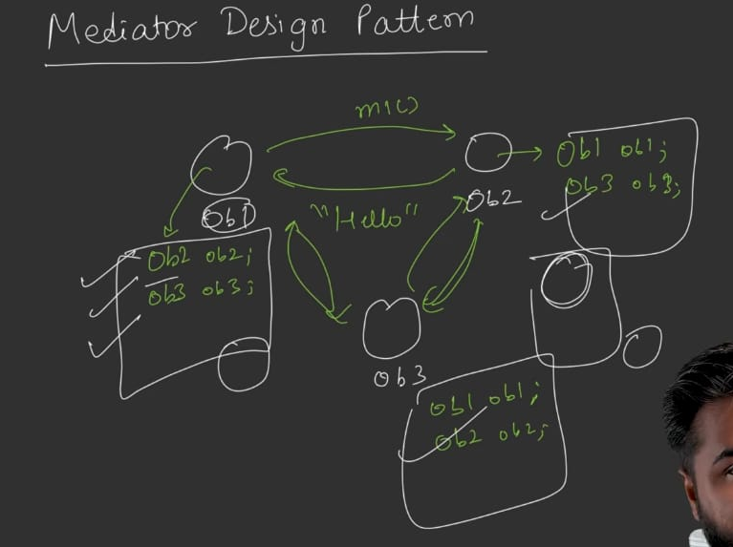

The Solution — Mediator Pattern

Core Idea
Introduce a Mediator object in the middle. All communicating objects (called Colleagues) hold a reference to the Mediator only — not to each other.

How It Works
text
Without Mediator:
OB1 ↔ OB2
↕ ↕
OB3 ↔ OB4
(full mesh — n(n-1)/2 connections)

With Mediator:
OB1 ─┐
OB2 ─┼──▶ Mediator ◀──┐
OB3 ─┤ │
OB4 ─┘ │
(star topology — n connections)

Communication Flow (With Mediator)
OB1 wants to talk to OB4:
- OB1 sends a message to the Mediator: send(OB4_ref_or_id, "message")
- The Mediator has references to all objects (OB1, OB2, OB3, OB4)
- Mediator forwards the message to OB4
- OB4 receives it (via its receive method)
Reply from OB4 to OB1: Goes through the mediator too — OB4 never knows OB1's reference.

Key Rules
- No object holds a reference to another object (only to the mediator)
- Only the mediator holds references to all objects
- All interactions flow through the mediator
- The mediator facilitates, not originates — it forwards messages

How Mediator Solves the Problems
Problem (Without Mediator) | Solution (With Mediator)
n(n-1)/2 connections | n connections (each object ↔ mediator)
Each object stores n-1 references | Each object stores 1 reference
Tight coupling between objects | Loose coupling — only coupled to mediator
Adding a new object requires touching all others | Just register with mediator — others unchanged
Memory explosion | Single list in mediator
The list of all objects exists in ONE place — the mediator. This eliminates duplication.
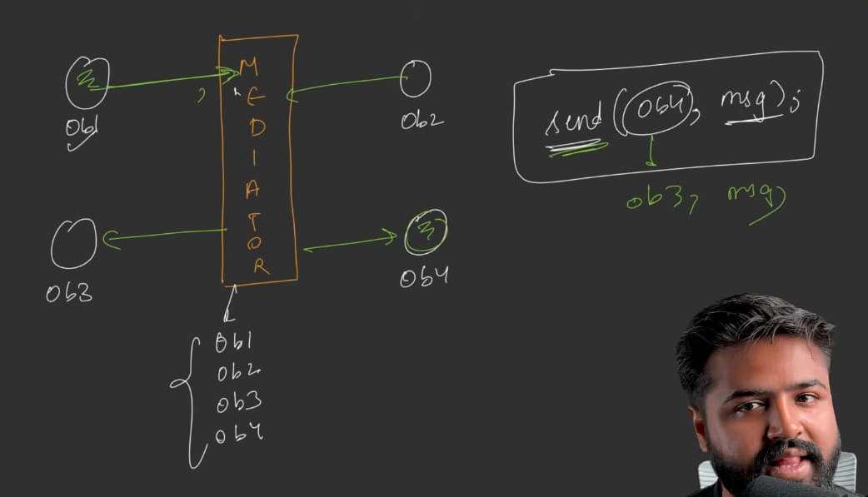

Example: Chat Room

What Is a Chat Room?
Multiple users interact with each other:
- Broadcast: One user sends a message to everyone
- Direct message: One user sends a message to a specific user
Additional features (to demonstrate complexity):
- Mute: One user blocks another user from receiving their messages
Rule: When a message is being delivered, if the recipient has muted the sender, don't deliver it.

Bad Design — Chat Room WITHOUT Mediator

Class Structure
User class fields:
cpp
class User {
string name; // User's name
vector<User> peers; // List of OTHER users (all other users!)
vector<string> mutedUsers; // Names of users this user has muted
};
Why vector of User in each User: User communicates with other users directly — needs references. Actually, a vector of user references (or User* in C++).

Methods
Method | Purpose
addPeer(User u) | Add another user to this user's peer list
mute(User u) | Add user to muted list (store name)
send(string message) | Broadcast to all peers (skip muted)
sendTo(User target, string message) | Send to a specific user (skip if muted)
isMuted(string name) | Check if a given name is in this user's muted list
receive(string from, string message) | Print incoming message

Detailed Behavior
addPeer: Push user into peers vector.
mute: Push the muted user's name into mutedUsers vector.
send (broadcast):
- Loop through each peer in peers
- Call peer.isMuted(this.name) — has the peer muted me?
- If yes → skip (continue)
- If no → call peer.receive(this.name, message)
sendTo (direct):
- Check if target.isMuted(this.name) — has the target muted me?
- If yes → skip
- If no → call target.receive(this.name, message)
isMuted(name): Loop through mutedUsers; if name matches any entry, return true; else false.
receive(from, message): Print "Notification: got '<message>' from <from>".

The Main Setup — Witnessing the Coupling Problem
Creating 3 users (Rohan, Neha, Mohan) requires:
cpp
User rohan("Rohan"), neha("Neha"), mohan("Mohan");

// Wire up all connections (n(n-1)/2 = 3 pairs = 6 directional refs for 3 users)
rohan.addPeer(neha);
neha.addPeer(rohan);
rohan.addPeer(mohan);
mohan.addPeer(rohan);
neha.addPeer(mohan);
mohan.addPeer(neha);
The explosion: For 3 users, 6 addPeer calls. For n users, n(n-1) calls — grows quadratically.

The "Mute" Complication
Implement mute (e.g., Rohan mutes Mohan):
cpp
rohan.mute(mohan);
Now every send/sendTo must check the mute status. The isMuted check permeates through all send/sendTo methods.
Problem: Adding mute functionality required:
- Adding a new field (mutedUsers)
- Adding a new method (mute, isMuted)
- Modifying send to check isMuted
- Modifying sendTo to check isMuted
Every new feature (login, typing indicator, block, etc.) would further bloat the User class.

Summary of Bad Design Problems
- n(n-1)/2 memory overhead — each user stores all peers
- Wiring is O(n²) — every pair must be connected manually
- Tight coupling — every user knows every other user
- Violates Open/Closed Principle — every feature addition modifies User
- Every feature bloats the User class
- Hard to test — one user depends on all others
- Not scalable — the design gets worse with each new user or feature
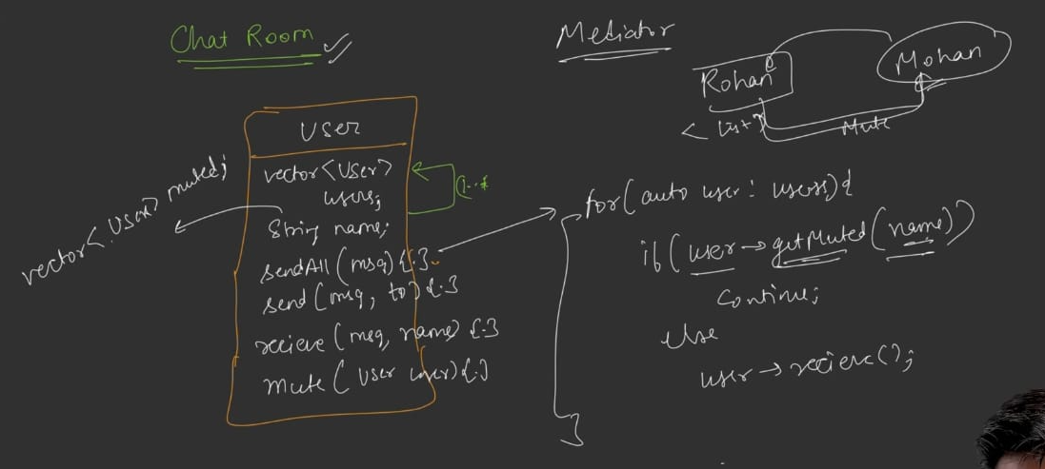

Code….see Notes
- Good Design — Chat Room WITH Mediator

Two Hierarchies
Mediator hierarchy:
- IMediator (abstract)
- ChatMediator (concrete — chat room)
Colleague hierarchy:
- IColleague (abstract — the "party" being mediated)
- User (concrete colleague)

Naming Note
The objects being mediated are called Colleagues (not "users", "subscribers", etc.) — this is the standard term for the mediator pattern.

IMediator (Abstract)

Methods (declarations only)
Method | Signature | Purpose
registerColleague | registerColleague(IColleague* c) | Register a colleague in the mediator's list
send | send(string from, string message) | Broadcast message to all colleagues (except sender)
sendPrivate | sendPrivate(string from, string to, string message) | Send to a specific colleague
Note: The abstract mediator doesn't keep the list of colleagues — that's for the concrete implementation.
No mute method in the abstract: Mute is an additional feature specific to ChatMediator — not part of the generic mediator contract.

IColleague (Abstract)

Fields
Field | Type | Purpose
mediator | IMediator* | Reference to the mediator

Methods (declarations only)
Method | Signature | Purpose
send | send(string message) | Broadcast via mediator
sendPrivate | sendPrivate(string to, string message) | Direct message via mediator
receive | receive(string from, string message) | Handle incoming message
getName | getName() : string | Return colleague's name

Constructor Behavior (in abstract)
cpp
IColleague(IMediator* m) {
this->mediator = m;
m->registerColleague(this); // Auto-register on creation
}
Key insight: As soon as a colleague is created, it automatically registers itself with the mediator via this. This is similar to the Observer pattern's attach behavior.

ChatMediator (Concrete Mediator)
Inherits IMediator.

Fields
Field | Type | Purpose
colleagues | vector<IColleague*> | List of all registered colleagues
mutes | vector<pair<string, string>> | Pairs of (who-muted, whom-was-muted)
Why pairs for mutes: Store as (muter, muted) — first string is who did the muting, second is who got muted. A vector of such pairs.
Why not a map: A map would give O(1) lookup, but the list is expected to be small — vector is simpler. (Alternative: map <string, set<string>> for O(1) lookups — leave as an optimization.)

Methods
registerColleague(IColleague* c): Push colleague into colleagues vector.
mute(string who, string whom): Push {who, whom} into mutes vector.
send(string from, string message) (broadcast):
- Print "Broadcast message from " + from + ": " + message
- Loop each colleague c in colleagues:
  - If c->getName() == from → skip (don't send to self)
  - Set isMuted = false
  - Loop through mutes pairs p:
    - If p.second == from AND p.first == c->getName() → isMuted = true; break;
  - If isMuted → skip this colleague
  - Else → c->receive(from, message)
sendPrivate(string from, string to, string message):
- Print "Private message from " + from + " to " + to + ": " + message
- Loop each colleague c:
  - If c->getName() != to → continue (only target)
  - Check if to has muted from (search mutes for {to, from})
  - If muted → print "Message muted" and return
  - Else → c->receive(from, message)
Mute check logic (used in both send and sendPrivate):
- Search the mutes vector
- A pair p matches if p.first == receiver_name and p.second == sender_name
- Meaning: receiver has muted sender
- If found → don't deliver the message

User (Concrete Colleague)
Inherits IColleague.

Fields
Field | Type | Purpose
name | string | User's name

Constructor
cpp
User(string name, IMediator* mediator) : IColleague(mediator), name(name) {}
Delegates to parent: Passes mediator to IColleague constructor (which stores it and calls registerColleague(this)).

Methods
getName(): Return name.
send(string message):
cpp
mediator->send(name, message);
sendPrivate(string to, string message):
cpp
mediator->sendPrivate(name, to, message);
receive(string from, string message):
cpp
cout << "Notification: got '" << message << "' from " << from << endl;
All message operations delegate to the mediator — the colleague has zero business logic of its own.

Main Setup — Witnessing the Simplicity
cpp
ChatMediator chat;

User rohan("Rohan", &chat);
User neha("Neha", &chat);
User mohan("Mohan", &chat);

// Rohan mutes Mohan
chat.mute("Rohan", "Mohan");

// Rohan broadcasts
rohan.send("Hello everyone");

// Mohan sends privately to Neha
mohan.sendPrivate("Neha", "Hey Neha");
Observations:
- No addPeer calls needed — registration is automatic
- No peer vectors in each User — only one mediator reference
- Only 1 chat object
- Only n connections (n=3 here, three users → 3 mediator refs)
- Adding a 4th user: just User x("X", &chat); — nothing else changes

Expected Output
text
Broadcast message from Rohan: Hello everyone
Notification: got 'Hello everyone' from Rohan (Neha)
Notification: got 'Hello everyone' from Rohan (Mohan)

Private message from Mohan to Neha: Hey Neha
Notification: got 'Hey Neha' from Mohan (Neha)
Note: Rohan muted Mohan — but the demo works because Rohan sending to Mohan is NOT prevented (mute only blocks Mohan → Rohan direction, not Rohan → Mohan).

UML Diagram Summary

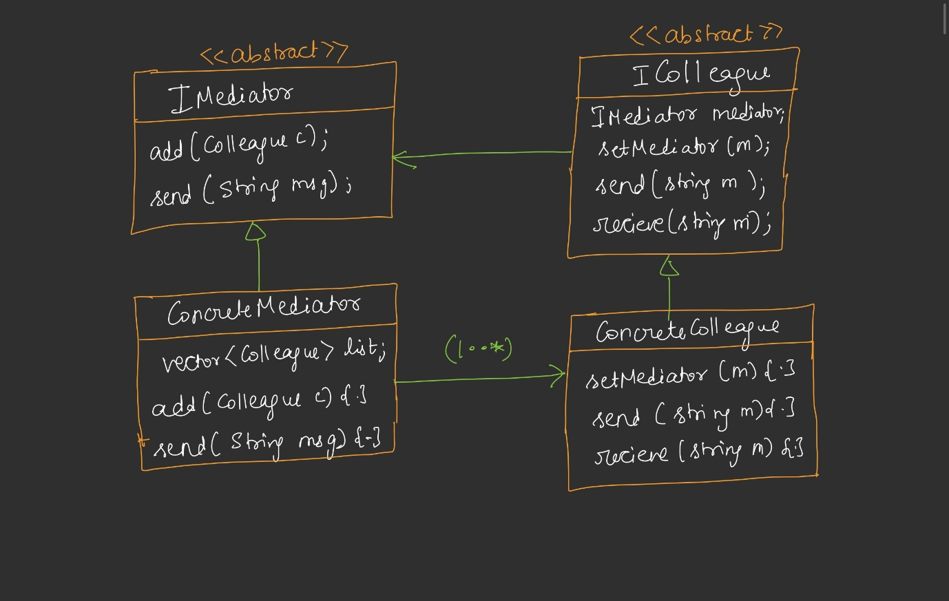Relationships
- IColleague has-a IMediator (composition, one reference)
- ChatMediator has 1..many IColleague (composition, list)
- ChatMediator ← IMediator (inheritance)
- User ← IColleague (inheritance)
Filled diamonds for strong composition (mediator and colleague references).
Code…see Notes

Mediator vs Observer — The Critical Difference

They Look Similar — But Aren't the Same
Both patterns:
- Have an abstract intermediary (Observable ↔ Mediator)
- Have many participants (Observers ↔ Colleagues)
- Have a registration mechanism (attach ↔ registerColleague)
- Have a notification mechanism (notify ↔ send)
- UML diagrams are nearly identical
- Code can look nearly identical

The Intent Difference (Critical)
Aspect | Observer | Mediator
Purpose | Notify all observers when the observable's state changes | Enable colleagues to communicate with each other
Trigger | State change in the observable | Direct user action (send message)
Direction | One-to-many (observable → all observers) | Many-to-many (through the mediator)
Meaning of "message" | A notification of change | An actual message from one colleague to another
Do participants interact with each other? | No — each observer independently reacts to change | Yes — via the mediator, they talk to each other
The list's role | Track who is interested in my state | Track who can talk through me

Real-World Decision Guide
Use Case | Pattern
Notification server: "When a new post is added, notify all followers" | Observer
Chat room: "Users talk to each other through the room" | Mediator
Stock price ticker: "Notify all traders when the price changes" | Observer
Online chess: "Two players play through the game server" | Mediator
YouTube subscribe: "Notify all subscribers of new upload" | Observer
Online matchmaking: "Users talk via the platform, never directly" | Mediator
Rule of thumb: If the participants don't care about each other individually — just want to be notified of a change — use Observer. If participants want to talk to each other through an intermediary — use Mediator.

Interview Insight
Being able to explain this intent difference (not just "they look similar") is a strong point in interviews. Interviewers expect you to know when to choose which.

Standard Definition
"The Mediator pattern defines an object that encapsulates how a set of objects interact. It promotes loose coupling by preventing objects from referring to each other explicitly, and lets you vary their interaction independently."
Breakdown:
- Encapsulates interaction: The mediator contains the "wiring" between objects
- Loose coupling: Colleagues don't reference each other
- Vary interaction independently: Change the interaction rules in the mediator without touching colleagues

Real-World Use Cases
Use Case | Why Mediator Fits
Chat Rooms (Slack, WhatsApp group, Discord) | Multiple users interact; users only know the room
Online Gaming Lobbies (Chess.com, Ludo, board games) | Players interact via the platform; can't reach each other directly
Air Traffic Control | Planes don't communicate with each other — they talk to the tower
UI Dialogs (complex forms where one field affects others) | Fields communicate through the dialog, not directly
Event Bus / Message Broker (conceptually) | Producers and consumers decoupled via the broker
Multiplayer Games | Player actions coordinated through the game server
General rule: Any application where multiple users/objects must interact but you don't want them holding references to each other — Mediator is the fit.

Key Takeaways
- Problem: Direct object-to-object communication leads to n(n-1)/2 connections, tight coupling, and O(n²) memory
- Solution: Introduce a mediator — objects reference only the mediator (n connections)
- Terminology: The mediated objects are called Colleagues; the intermediary is the Mediator
- Two hierarchies: IMediator (abstract) → ChatMediator (concrete) and IColleague (abstract) → User (concrete)
- Auto-registration: Colleagues register themselves with the mediator in their constructor (calls registerColleague(this))
- Delegation: Colleagues implement operations by delegating to the mediator — the mediator contains the coordination logic
- Feature addition is easy: Mute functionality was added to ChatMediator without touching the abstract mediator or colleague contract — OCP-friendly
- Loosely coupled: No colleague references any other colleague
- Same UML as Observer — different intent: Observer = "notify of state change"; Mediator = "enable communication between participants"
- Chat rooms are the canonical example; online games and ATC are also common

One-Line Summary
Mediator introduces a central object through which many participants communicate, eliminating n(n-1) cross-references and reducing coupling — with the intent of enabling peer-to-peer communication, not state-change notification (that's Observer).

